LAB Logbook

Lab 1
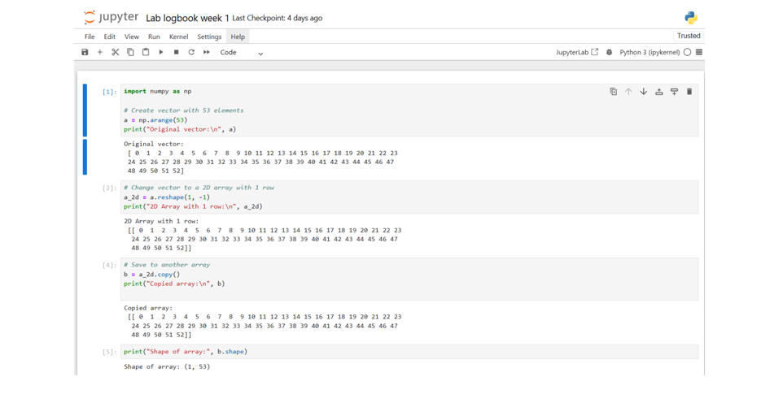
Lab 2
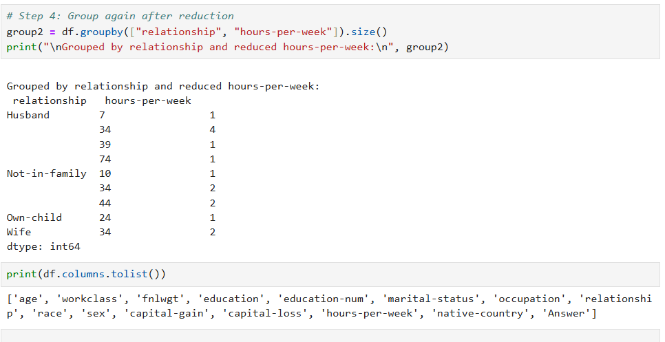

Lab 3
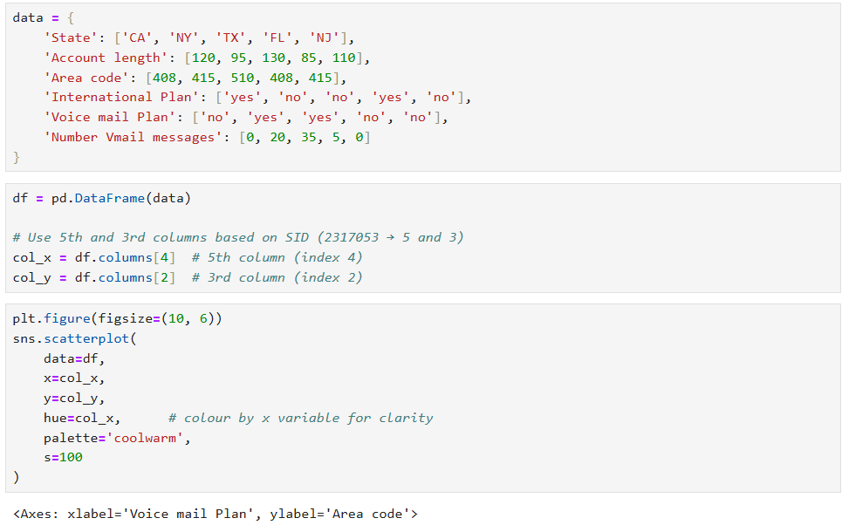
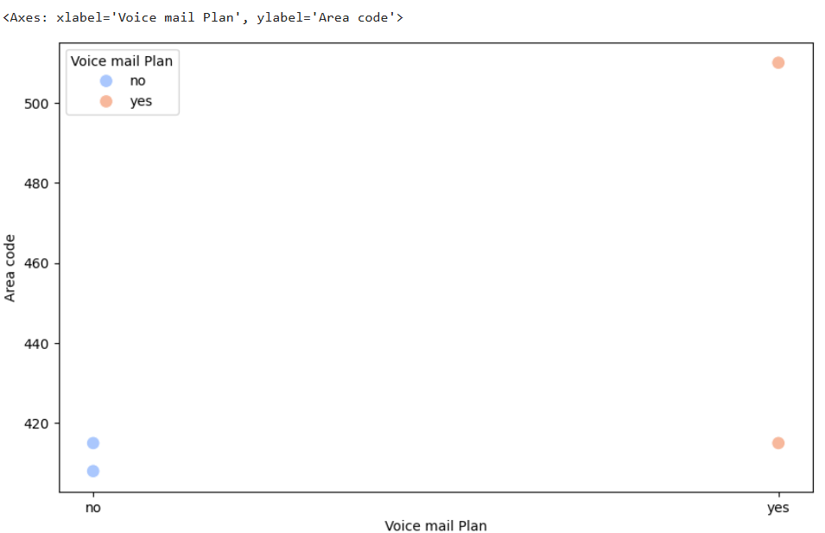
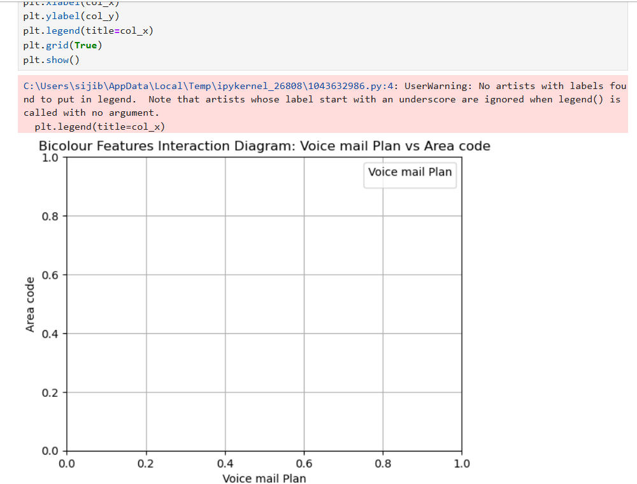
Lab 4

Lab 5

Lab 6

Lab 7

Lab 8

Lab 9

Lab 10

Lab 11

Lab 12

